**INTRODUCTION**

Chemical technology helps us study, develop, research and deploy all the statistical, theoretical and experimental facts behind the functioning and processes involved in the system. It ranges from the tasks as big as designing a nuclear reactor to as mini as measuring its surrounding temperature. Everything from nuclear fusion to modifying day to day materials comes under its study.

Team Drishti is also working on many aspects of Chemical Technology for the betterment of society. As the rate of energy consumption is continuously being increased in the recent years, scientists and engineers have to concentrate on developing new energy technologies and thermal management systems. Taking it as a challenge, Team Drishti has worked on Simulation of Heat Pipe for better Heat Transfer and Waste Heat Management in various industrial processes. Along with this, Team Drishti has also participated in the Chemical Engineering Techfest of IIT Bombay namely Azeotropy.

**HEAT PIPE**

Heat transfer is having importance in many different areas, for example, solar application, waste heat recovery, electronic cooling in computer, and all other electronic components which generate heat. Generation of heat takes place in many applications and this heat must be transferred or removed from the immediate environment and ejected in some suitable heat sink. Therefore, it is necessary to find more efficient method of removing heat from source to sink. Heat pipe is one of such promising technology which can be used to transfer large amount of energy over a small temperature gradient because of large latent heat transfer associated with the phase change processes. Their simple design, cost effectiveness, high efficiency, good compactness, reliability and durability have made them very attractive for many industrial applications like waste heat recovery, heating ventilation and air conditioning, electronic cooling, human body temperature control, cooling of gas turbine rotor blades, solar energy etc. It is used to improve the thermal performance of heat exchanger and with increasing energy saving application with commercial use.

**Overwiev of Heat Pipe:-**

The best-known capillary driven two phase system is the” HEAT PIPE”. Heat pipe is defined as a highly effective passive device which is used to transmit heat at high rates over considerable large distance with very small temperature drops with simple construction, easy control and no external pumping power

Heat pipe has three main basic components

* Container
* Working fluid
* Wick

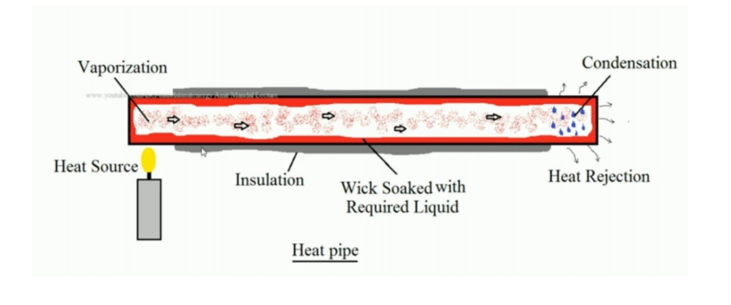

A typical heat pipe consists of a sealed tube or pipe (cylindrical shape is not necessary, it can be of any shapes as per the application) made of a material that is compatible with the working fluid. Such examples are aluminium is used as a material when ammonia is used as a working fluid or copper is used as a material when water is used as a working fluid. This container is divided in three parts along the length.

* Evaporator Section
* Adiabatic Section
* Condenser Section

In evaporator section (heat source), heat is supplied to the working medium so it will vaporise. Adiabatic section is highly insulated section to minimise the heat loss to or from the surrounding. In condenser section (heat sink), heat is rejected to the heat sink by the working medium so it will be converted into liquid. It is not necessary to have only one source or sink; it may have more than one source and sink as per the requirement of the application. The heat pipe is partially filled with a working fluid and then sealed. Once the filling is done, it is sealed. Mass of the working fluid is chosen in such a way that heat pipe contains both vapour and liquid over the operating temperature range. The wick is selected as per the working fluid and the application.

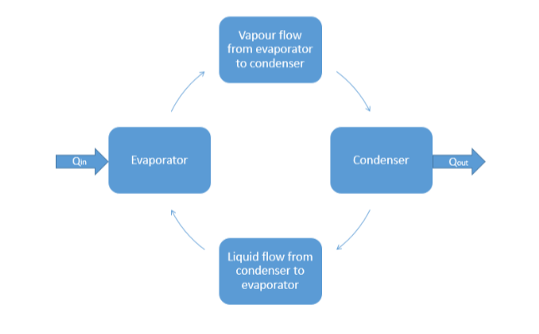

**Design considerations and Factors affecting heat pipe performance**

(i) Material used for container

(ii) Properties of Working Fluid

(iii) Types of Wick Structure

(iv) Source and Sink temperature

(v) Power input at evaporation section

(vii) Orientation of heat pipe

**Operating Parameters**

(i) Capillary action

(ii) Filling Ratio

(iii) Surface Tension

(iv) Inclination angle

(v) Sonic limit

(vi) Boiling limit

(vii) Entrainment Limit

**Numerical Model:**

The computational analysis was carried on Ansys 16. the geometry of Heat Pipe was developed according to its application in Design Modeller and mesh was generated. Near wall mesh was kept highly refined compared to the other mesh as to capture the minute changes occurring near the wall. The computational simulation is carried out to study two phase flow and heat transfer phenomena in the Heat Pipe by using FLUENT 16. The volume of fluid method is used to simulate the multiphase flow. Depending upon the use of Heat Pipe in some cases the body force term was included and, in some cases, it was neglected. The Body force term was considered by activating the acceleration due to gravity. A transient simulation with a variable time step which varies in the range of 0.0001 to 0.0005 sec is carried out to model the dynamic behaviour of the multiphase flow. The time step is selected based on the Courant number, which is the ratio of the time step to time require for fluid to move across the cell. The numerical simulation is considered to be converged when the residuals for mass and velocity components are reduced to 10-6.

**Results:**

Various parameters were considered during the solution of numerical model and from the solution results were plotted regarding temperature contour and volume fraction of Steam or liquid.

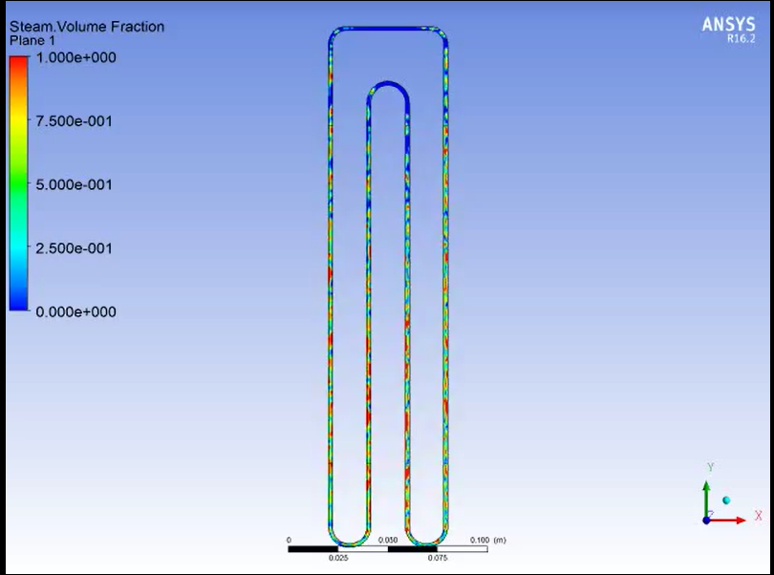

**Centrifugal Pump:**

Pumps in the chemical industry are very crucial to supply energy for transporting or compressing fluids. Working on the basic principle of conservation of energy, pumps serve in a wide range of applications such as aeration, in the car industry for water-cooling and fuel injection, in the energy industry for pumping oil or natural gas or for operating cooling towers. Pumps are also used in the medical industry in artificial replacement of body parts such as artificial heart and penile prosthesis. Centrifugal pumpsare the most widely used and hence play an important role in industrial operations. Along with pumps, components like valves help us to control the process variable of flow rate. With the growing demands for digitalisationand advanced process control, the automated detection of flow parameters is yet another milestone to be achieved across all industries. This project aims at developing a electrically powered Centrifugal Pump which can varies its flow rate depending upon the requirement. It is an amalgamation of Fluid Mechanics and process control.

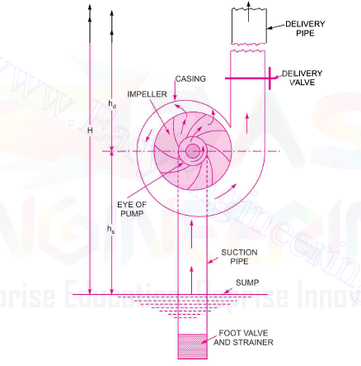

Pumps are hydraulic machine which develops hydraulic energy (Pressure Energy ) by converting mechanical energy. In centrifugal Pumps , the mechanical energy is converted to hydraulic energy (Pressure Energy) by means of centrifugal force acting on the fluid. In a sense, centrifugal pumps are reverse of inward radial flow reaction turbine which implies that the flow in centrifugal pump is in radial outward direction. Centrifugal pump works on the principle of Forced vortex flow which means that when a certain mass of liquid is rotated through external torque, the rise in the pressure head of the liquid takes place. Due to this pressure head , liquid can be lifted to high level.

There are four main parts of the centrifugal pump

* Impeller
* Casing
* Suction pipe
* Delivery pipe

The main component of the pump is Impeller. It is the rotating component of the centrifugal pump and it contains series of vanes. This impeller is mounted on a shaft which is then connected to the shaft of the motor. Casing is an air tight passage surrounding the impeller of the pump. Casing of the pump can be of three types volute casing , vortex casing and casing with guide blades. A pipe whose one end is connected to the inlet of the pump and other in the water sump is known as suction pipe whereas the pipe whose one end is connected to the outlet of the pump and other delivers liquid to required level is known as Delivery Pipe.

**Flow Diagram:**

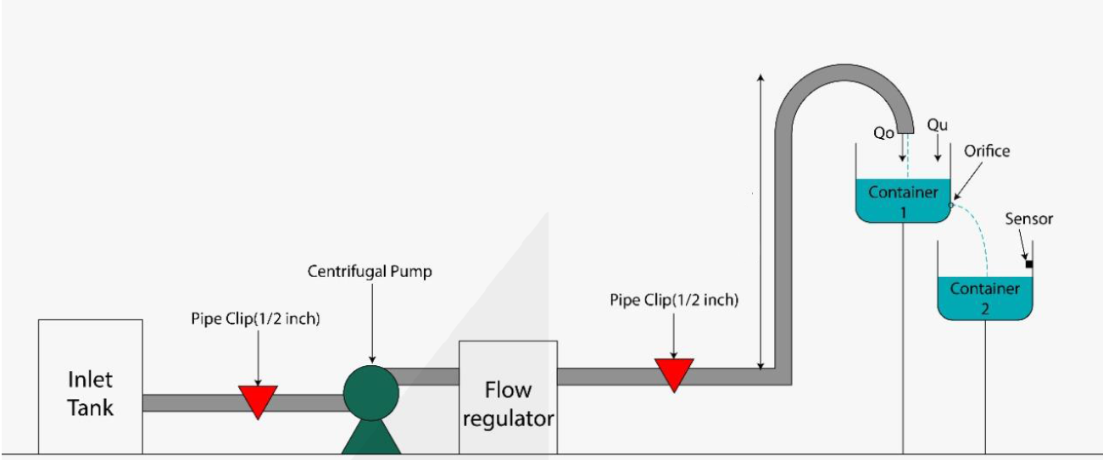

**Design Parameters taken into consideration:**

1. Suction Head
2. Delivery Head
3. Cavitation
4. Required Flow Rate
5. Impeller blade height and width
6. Impeller blade angle
7. Number of Blades on impeller

Considering the above design parameters and various calculations about the efficiency, power output and work done by the pump, we have designed various impellers and the following two designs of the impeller were giving suitable outcomes.

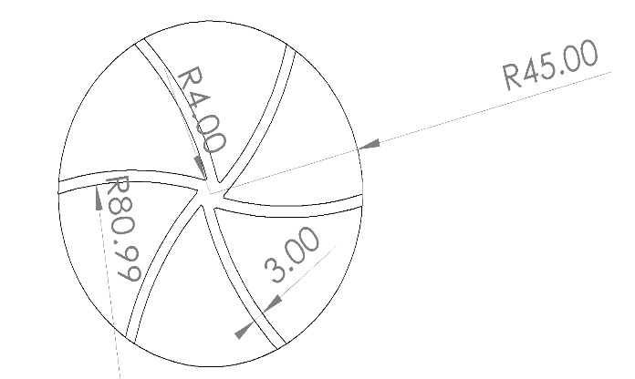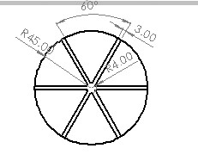

**Final Model:**



After working on various calculations and considering all the important parameters, the final model of the centrifugal pump was manufactured. The impeller diameter was of 90 mm having 6 blades each 3 mm thick and 35 mm in height. The base motor of Chinese motor having nearly 18000 rpm was Selected and impeller was coupled with the motors shaft. He casing of the centrifugal pump was volute casing of 130 mm in diameter and 45 mm height. The deliver pipe was around 3.5 to 4 m in length and hence liquid was pushed to that height with outlet flowrate of nearly 5 litres/min. Among various sensors, in order to measure the flow rate of unknown liquid we have used water Flow sensor which directly gives the value corresponding to the Flow Rate. In order to control the Flow Rate we have developed 2 technologies, one was with the help of the mechanical valve by which we can manually set the value of the desired Flow rate and the other was with the use of motor driver citron. With the help of the Citron we can control the rpm of the motor as per the desired output flow rate.

**Waste Heat management**

In chemical industries most of the reaction that takes place are exothermic reactions. In simple words exothermic processes are the reactions in which heat is liberated. Generally in most of the chemical industries, the heat liberated during a process is utilized in pre-heating of the reactants or in some other processes involving high temperature requirements. Therefore one question arises what if the heat liberated in a process is more than the required heat of pre-heating of reactants or because of some reasons we are not able to utilizing it in a efficient way, so for this kind of situation we have designed a process of utilizing the heat in the generation of electricity. Our project aim is to design and simulate a waste heat management flowsheet and to increase the efficiency of plant by using waste heat and to make optimum use of fuel. We are using ASPEN PLUS software to design the flowsheet and simulate it under given conditions.

In order to study about various process taking place in industries , we learned about the three types of Flow Diagram Block Flow Diagram, Process Flow Diagram and Piping & Instrumentation. The study of these flow diagrams helps in dertermining the process and the direction of process taking place in the industries. Along with the flow Diagram , Componens in the Flow Diagram also matters lot in determing the energy transffer in the process. Following are the main components of the Flow Diagram:

* Heaters
* Heat Exchangers
* Generators
* Tray towers
* Packed Columns

In order to developed our own process and its Flow Diagram , we went across few previously developed processes like

* Air Dryer and Filter System
* Dual feed
* Electricity
* Combined cycle power plant

Thus after developing thorough knowledge about the unit processes and their Flow Diagram, we started developing our own processes and their flow Diagram amd the using ASPEN Plus to determine the efficiencies of the process. We have developed three different Flow sheets for three different process like Distillation , CO2 gas Capture plant and Electricity producing Plant

**Flow sheet :**

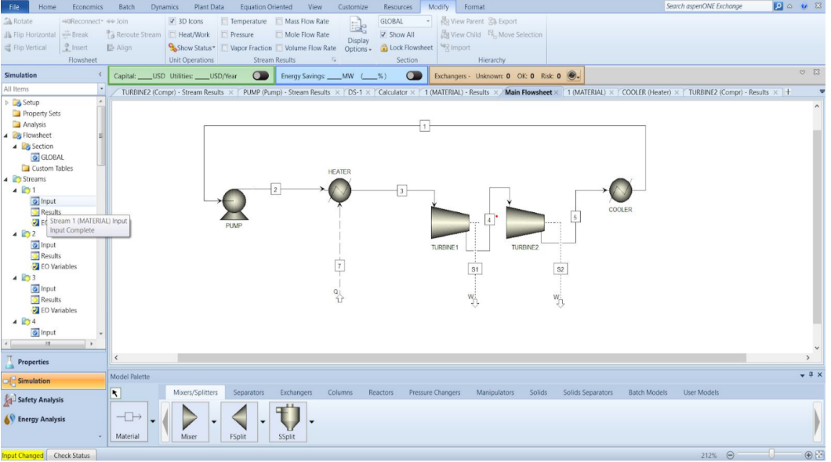

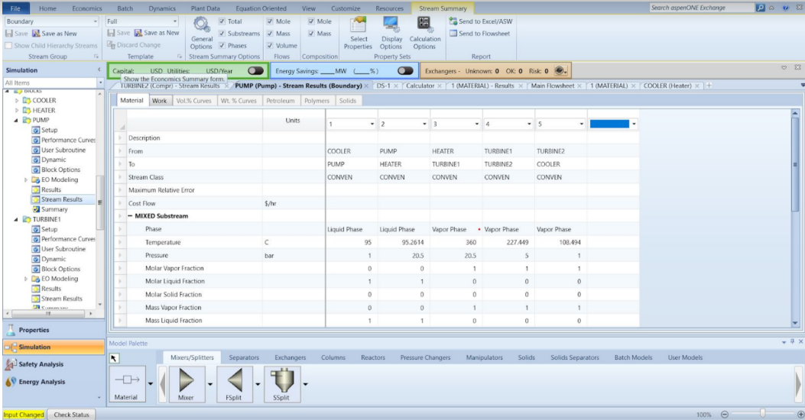

It is clear from the Flow diagram that water is used as feed. After going through the pump and with raise in pressure energy, water enters the heat exchanger and gets converted in steam. This steam is allowed to flow through the blades of the turbine and hence energy is produced through the rotation of the turbine blades. Here we have used two turbines to increase the efficiency of the plant. Thus after going through turbines steam is passes through condensor and again gets converted to water which is passed to the pump. The heat produced in the condensor can be used to rise the temperature of water in heat exchanger.